# **Admin Menu**

## 1 Institution Management

### 1.1 Add a New Institute

* Institution ID (Auto-generated)
* Institution Name (Required)
* Institution Type (Dropdown: School, College, University, Corporate)
* Institution Email (Required)
* Institution Phone (Required)
* Website URL
* Date of Establishment
* Head Office Address
* Street
* City
* State/Province
* Postal Code
* Country
* Primary Contact Person
* Primary Contact Full Name
* Primary Contact Job Title
* Primary Contact Email
* Primary Contact Phone Number
* Institution Status (Active/Inactive)

### 1.2 Add a New Branch

* Select Institution
* Branch ID (Auto-generated)
* Branch Name (Required)
* Branch Code (Optional)
* Branch Manager (Dropdown from institutional staff profiles)
* Branch Email (Required)
* Branch Phone (Required)
* Branch Address
* Street
* City
* State/Province
* Postal Code
* Country
* Branch Status (Active/Inactive)

### 1.3 Add a New Lab

* Lab ID (Auto-generated)
* Lab Name (Required)
* Branch Assignment (Select relevant branch)
* Number of Seats (Required)
* Lab Equipment (List of equipment like computers, headsets, etc.)
* Lab Schedule (Days/Times the lab is operational)
* Lab Manager (Select from staff)
* Lab Status (Active/Inactive)

### 1.4 Browser Lists (Institutions/Branches/Labs)

Show lists of institutions added, branches added and labs added in tabular form where the admin can go and see the already added details and edit/ make active or inactive/delete using the action buttons.

|  |  |  |  |  |  |  |  |  |  |
| --- | --- | --- | --- | --- | --- | --- | --- | --- | --- |
|  |  |  |  |  |  |  |  |  | Action |
|  |  |  |  |  |  |  |  |  |  |

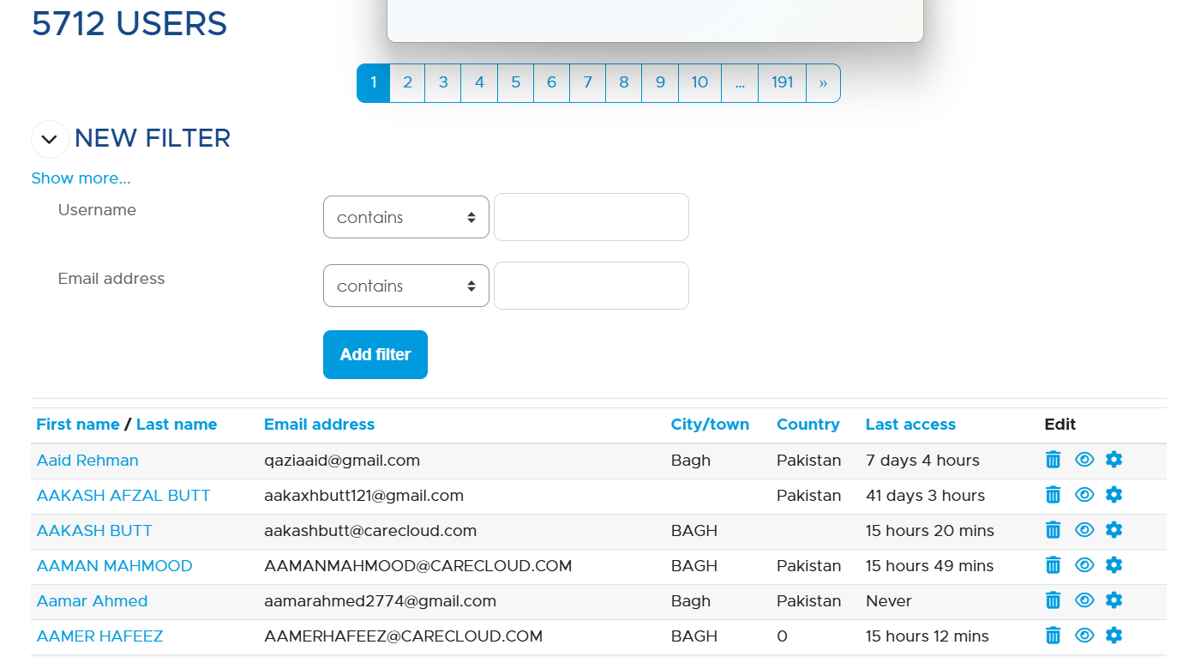

## 2 User Management

### 2.1 Add a New User

User Type (Student/Employee)

User id (student/employee id)

First Name

Last Name

Email address

Phone number

City

State

Province

Country

Address

Designation/Job Title (mandatory for employee account)

Hiring Date/Joining Date

Grade (Mandatory for Student Role)

User Roles = Learner / Instructor / Manager / Admin (Select options) one user can have multiple roles

Assign Institute (drop down)

Assign Branch (drop down)

Assign Lab (dropdown)

2.2 Bulk User Import/Update

1.6 Access Rights Management